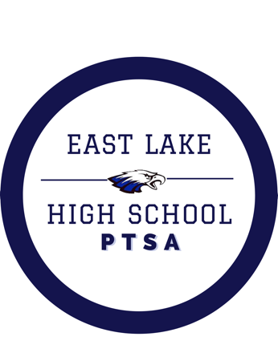

WELCOME BACK EAGLES!

Your 2024-2025 PTSA Board is excited to welcome students & staff back to campus. Membership sales and Sponsorships are our main fundraisers. Funds raised will be used to support student enrichment by providing funding for special projects and classroom supplies. The PTSA will also provide funding for staff appreciation events. We love to show the teachers and support staff how much we appreciate them!
Please help us to build a stronger community by joining the ELHS PTSA.
How can I join?
You can join by clicking the link below: https://elhsptsa.givebacks.com/store?limit=21&live=true`
Do you have Business Sponsorships?
YES! Business Sponsorships start at just $150 and are critical to funding PTSA Programs. Please contact us at ptsaelhs@gmail.com for more information or click the following link https://elhsptsa.givebacks.com/store?limit=21&live=true`
We LOVE our community sponsors!
Thank you in advance for your support! We appreciate your contribution to the East Lake High School community.
Stay in touch by following our Facebook page @EastLakeHSPTSA
Questions? Email us at ptsaelhs@gmail.com

Kind Regards,
East Lake High School PTSA Board

Monica Morris, President Cally Wingfield, VP
Karen Thomas, Treasurer Dr. Hatfield, Secretary

